Opening Night: The Wacko World of Charlie Spillar First Peek
March 19, 7- 8:30 pm
Free
Everyone is Invited

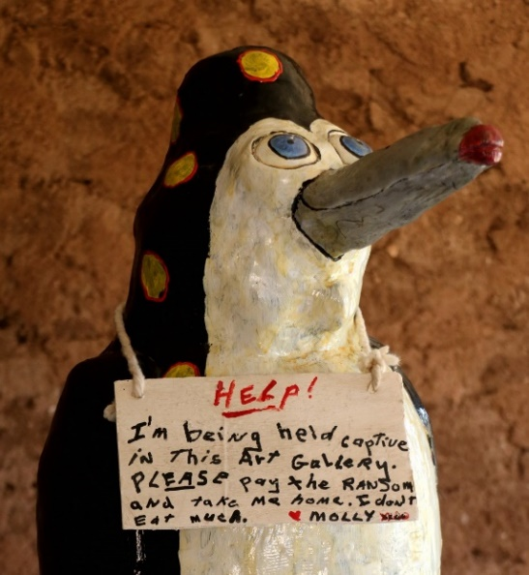
Join us to see the happy art of Charlie Spillar, We will miss longtime volunteer Charlie Spillar but are so pleased his artwork lives on. Most know Charlie from the Magic Carpet Golf statues he saved and moved to Valley of the Moon or his efforts to assure veterans are able to receive Hyperbaric Oxygen Therapy (HBOT) through Healing Arizona Veterans. Charlie’s family donated his art to the nonprofits dear to Charlie: Healing Arizona Veterans and Valley of the Moon. A retrospective, "The Wacko World of Charlie Spillar", will be displayed in Historic Frank and Rose's Adobe House. Experience Charlie’s happy artwork and enjoy a unique outdoor parlor complete with refreshments and Celtic harp music by

