Outside event policy
Private parties
Three hours of exclusive use of Valley of the Moon with at least one helpful staff person, who just might be a magical creature, such as a fairy. Use of outdoor tables and chairs
Costs:
$250 for up to 40 people + $50 refundable deposit

$50 for each additional hour

Details:
Larger groups discouraged and would require negotiation, refer to Jenni.
Weddings will be handled under the wedding policy.
Volunteers working 5 outside events can hold their own private party for free!

Public Parties
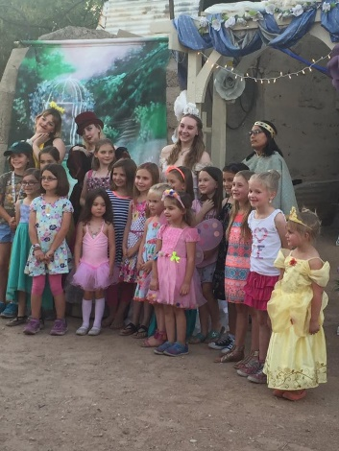
A party group can buy all the tickets for a specific tour at full price (Set price may be established for each play, considering tour size). If a set price for booking a tour is established for the play, that set price is used instead of booking at full price.
Details: larger groups would require negotiation.
If we have a food vender, ask vender if they will offer a party package for food. Otherwise, group is permitted to bring in food and informed that Valley of the Moon is not responsible for keeping other guests away from party food.
A volunteer should be assigned to facilitate group purchases, etc., until they start their tour.
Advance purchase of tour required. Deposit and property use agreement does not apply to public parties

Party Favors/ Discounts:
The person booking the party is authorized to offer the following discounts:
100 carnival tickets for $18.
Souvenir magic cup and a drink (soda, chocolate milk, capri sun juice or water) for $5; if purchasing more than 10, cost reduced to $4.
Valley of the Moon tees $12.
Other bulk discounts possible, consult with board liaison

Status as of 6/22/2018:
Needs:
1. Recruitment of crew of at least 4 people willing to work outside events and identification of a point person to do scheduling must occur prior to rolling out. (Currently Grace, Autum, Carrie and Jenni are willing)
2. The property use agreement form should be updated
3. Once adobe house finished, cost for use to be determined.
4. Consider creating a magical creature add-on option where individuals agree to attend a party for a set price in costume such as mermaid, Cat in the Hat, etc.

